# UML Diagram:

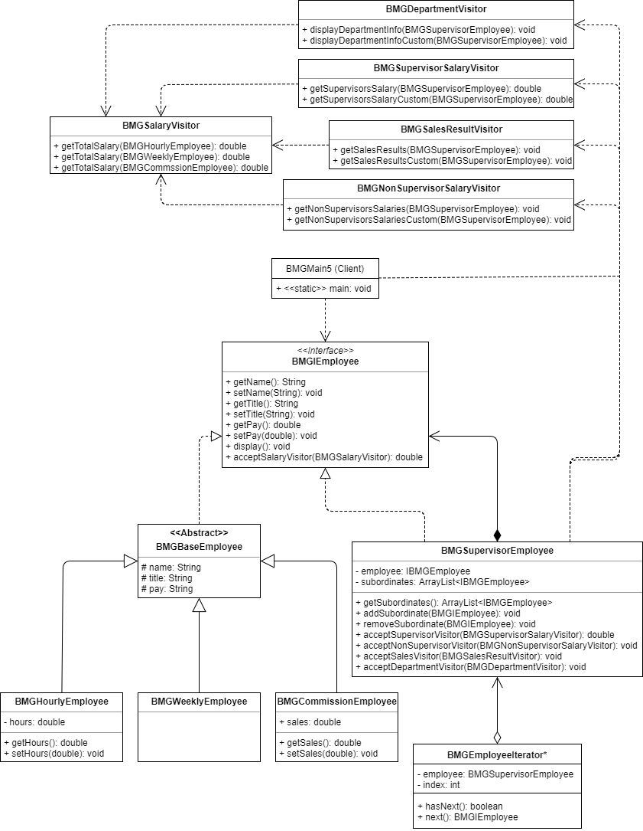

# Pseudocode:

**Class BMGSupervisorEmployee:**

* display()

Call the display method on the employee wrapped by this object.

­Use an iterator (Custom or from a library) to traverse over each of the subordinates of this object:

Print an indentation upon each traversal.

Call this method on each employee traversed to.

**Class BMGNonSupervisorSalaryVisitor:**

* getNonSupervisorsSalaries(BMGSupervisorEmployee)

Declare a decimal variable: nextSalary.

Declare an object pointer that can point to an object conforming to the BMGIEmployee interface: nextEmployee.

­Use an iterator (Custom or from a library) to traverse over each of the subordinates of the received BMGSupervisorEmployee object:

Point nextEmployee to the object traversed to by the iterator.

If nextEmployee is not an instance of the BMGSupervisorEmployee class:

Set nextSalary to the return of nextEmployee’s acceptance of a BMGSalaryVisitor object.

Print the nextEmployee’s name and nextSalary.

Else:

Tell nextEmployee to accept this object.

**Class BMGSupervisorSalaryVisitor:**

* getSupervisorsSalary(BMGSupervisorEmployee)

Declare a decimal variable: salary.

Declare an object pointer that can point to an object conforming to the BMGIEmployee interface: nextEmployee.

­Use an iterator (Custom or from a library) to traverse over each of the subordinates of the received BMGSupervisorEmployee object:

Point nextEmployee to the object traversed to by the iterator.

If nextEmployee is an instance of the BMGSupervisorEmployee class:

Add the return of nextEmployee’s acceptance of this object to salary.

Return salary

**Class BMGSalesResultVisitor:**

* getSalesResults(BMGSupervisorEmployee)

Declare a decimal variable: nextSalary.

Declare a decimal variable: nextSales.

Declare an object pointer that can point to an object conforming to the BMGIEmployee interface: nextEmployee.

­Use an iterator (Custom or from a library) to traverse over each of the subordinates of the received BMGSupervisorEmployee object:

Point nextEmployee to the object traversed to by the iterator.

If nextEmployee is an instance of the BMGCommissionEmployee class:

Set nextSales to the sales of nextEmployee.

Set nextSalary to the return of nextEmployee’s acceptance of a BMGSalaryVisitor object.

Print nextEmployee’s name and nextSales and nextSalary.

Else:

If nextEmployee is an instance of the BMGSupervisorEmployee class:

Tell nextEmployee to accept this object.

**Class BMGDepartmentVisitor:**

* displayDepartmentInfo(BMGSupervisorEmployee)

Declare a decimal variable and set it to the return of the received BMGSupervisorEmployee’s acceptance of a BMGSalaryVisitor object: departmentSalary.

Declare a decimal variable: nextSalary.

Declare an object pointer that can point to an object conforming to the BMGIEmployee interface: nextEmployee.

Print the name and title of the received BMGSupervisorEmployee object and nextDepartment.

­Use an iterator (Custom or from a library) to traverse over each of the subordinates of the received BMGSupervisorEmployee object:

Point nextEmployee to the object traversed to by the iterator.

Set nextSalary to the return of nextEmployee’s acceptance of a BMGSalaryVisitor object.

Print an indentation.

Print the name and title of nextEmployee and nextSalary.

departmentSalary = departmentSalary + nextSalary.

Print an indentation.

Print departmentSalary.